

* **Project Name**: Dog Breed Identifier
* **Group Members**: Aditya Bhoir
* Rohit Kamble
* **Date**: 24/10/2023

**Introduction**

The Dog Breed Identifier project is a cloud-based solution that utilizes Azure services to identify dog breeds. The project is designed to be a scalable, reliable, and easy-to-use solution for anyone who wants to identify the breed of their dog.

The project utilizes Azure Custom Vision, a machine learning service that is used to train a model to identify dog breeds. The Custom Vision model is trained on a large dataset of dog images. This allows the project to accurately identify a wide variety of dog breeds.

The project is deployed on an Azure Virtual Network (VNet). The VNet is a secure and isolated network environment that allows the project's components to communicate with each other. The project's components are deployed on Azure Virtual Machines (VMs). The VMs are used to host the project's web servers and the Custom Vision model.

The project is designed to be scalable. The number of VMs can be increased to handle a large number of users. The project is also designed to be reliable. The VMs are configured with high availability features to ensure that the project is always available.

The project is easy to use. Users simply need to upload an image of a dog to the project's web page. The project then uses the Custom Vision model to identify the breed of the dog in the image. The project displays the results of the identification on the web page.

The Dog Breed Identifier project is a valuable tool for anyone who wants to identify the breed of their dog. The project is accurate, scalable, reliable, and easy to use.

**Objectives**

The goals of the Dog Breed Identifier project are to:

* Develop a machine learning model that can accurately identify dog breeds.
* Create a cloud-based solution that is scalable and reliable.
* Develop a user-friendly interface that is easy to use.

**Benefits**

The Dog Breed Identifier project provides the following benefits:

* Accurate dog breed identification: The project's Custom Vision model is trained on a large dataset of dog images. This allows the project to accurately identify a wide variety of dog breeds.
* Scalable and reliable architecture: The project's architecture is designed to be scalable and reliable. The project can be scaled to handle a large number of users, and the project's components are designed to be highly available.
* Easy to use: The project is easy to use. Users simply need to upload an image of a dog to the project's web page. The project then displays the results of the identification on the web page.

**Azure services**

1. **Azure Virtual Machine:**
   * A Virtual Machine (VM) is a software-based emulation of a physical computer.
   * It allows running multiple operating systems on a single physical machine.
   * VMs provide isolation, resource allocation, and flexibility for various purposes, including server virtualization and development/testing environments.
   * VMs are managed by hypervisors and are integral to cloud computing platforms.
   * They offer security and isolation, support snapshots and cloning, and allow for live migration.
2. **Azure Application Gateway:**
   * Azure Application Gateway is a load balancing solution and web traffic manager that enables you to distribute network traffic across multiple services or virtual machines to ensure high availability, scalability, and security for your web applications.
   * It acts as an entry point for your web applications and provides features such as SSL termination, session affinity, URL-based routing, and web application firewall (WAF) for enhanced security.
   * Application Gateway is a fundamental component for building highly available and performant web applications in Azure.
3. **Azure Custom Vision:**
   * Azure Custom Vision is a cloud-based service provided by Microsoft Azure that enables the creation and training of custom machine learning models for image classification.
   * It simplifies the process of building custom image classifiers by allowing users to upload images, label them, and train a model to recognize objects or patterns in those images.
   * It's particularly useful for tasks like recognizing specific objects, faces, or text within images.
   * Azure Custom Vision is designed for users with varying levels of machine learning expertise and offers pre-built domains for specific use cases, making it accessible and effective for a wide range of applications, from healthcare to manufacturing and beyond.
4. **Azure Web Application Firewall**

* A Web Application Firewall (WAF) is a security solution that protects web applications from various online threats and vulnerabilities.
* It filters and monitors incoming web traffic, blocks malicious requests, and helps prevent attacks like SQL injection and cross-site scripting.
* WAFs operate at the application layer (Layer 7), providing granular security control, and often include custom rule creation and logging capabilities.
* They are used to safeguard sensitive data, maintain compliance with regulations, and continuously adapt to evolving threats, making them a crucial component of web security.

**Code Overview**

**index.html**

<!DOCTYPE html>

<html>

<head>

<style>

/* CSS Styles for the page */

/* ... (CSS styles) ... */

</style>

</head>

<body>

<h1>Dog Breed Prediction</h1>

<form id="upload-form">

<input type="file" id="photo" name="photo">

<input type="submit" value="Predict Breed">

</form>

<div id="results">

<p>Results will display here...</p>

</div>

<script src="dog-app.js"></script>

</body>

</html>

* **Description**: This is the HTML file that acts as Frontend which will be seen by the users. It defines the basic layout, including a title, a form for uploading an image, and a container for displaying the prediction results.

**dog-app.js**

// app.js

// Custom Vision prediction API

const predictionKey = 'my prediction key';

const predictionUrl = 'my prediction url’;

// Get DOM elements

const uploadForm = document.getElementById('upload-form');

const results = document.getElementById('results');

// Listen for upload

uploadForm.addEventListener('submit', (e) => {

e.preventDefault();

handleUpload();

});

// Handle upload

async function handleUpload() {

const file = document.getElementById('photo').files[0];

const formData = new FormData();

formData.append('photo', file);

// Make prediction

const response = await fetch(predictionUrl, {

method: 'POST',

headers: {

'Prediction-Key': predictionKey

},

body: formData

});

const data = await response.json();

// Display results

const resultsHTML = [];

for (let prediction of data.predictions) {

const breed = prediction.tagName;

const probability = prediction.probability * 100;

const percent = probability.toFixed(2);

resultsHTML.push(`

<p>Breed: ${breed}</p>

<p>Probability: ${percent}%</p>

`);

}

results.innerHTML = resultsHTML.join('');

}

**Description**:

* This is the JavaScript code that handles the functionality of your web application.
* It listens for form submission and prevents the default form behavior.
* It fetches the selected image file and sends it to the Custom Vision prediction API for analysis.
* Once the prediction results are obtained, it dynamically updates the HTML page to display the predicted dog breed and its probability.

**Data Preparation**

**Labeling and Organizing Images:**

1. **Labeling:** Begin by labeling your images with relevant tags. Tags are essential for teaching the AI model to recognize and classify objects. For a dog breed classification model, each label might represent a different breed (e.g., "Labrador Retriever," "Golden Retriever," etc.).
2. **Quality and Quantity:** Ensure that the images are of high quality. Clear, well-lit images lead to better model accuracy. It's recommended to have at least 50 images per label as a starting point to train the model effectively [[3](https://learn.microsoft.com/en-us/azure/ai-services/custom-vision-service/getting-started-improving-your-classifier)].
3. **Variety:** Include a diverse range of images. This means images of different dog breeds, different angles, backgrounds, lighting conditions, and variations in the dog's pose, age, and color. A variety of images helps the model generalize and perform well in real-world scenarios [[2](https://learn.microsoft.com/en-us/azure/ai-services/custom-vision-service/getting-started-improving-your-classifier)].
4. **Organized Dataset:** Maintain a well-organized dataset. You can create folders for each label, and within each folder, store images corresponding to that label. A well-structured dataset makes it easier to manage and upload images to the Custom Vision service.

**Uploading Images:**

1. **Use Azure Custom Vision Service:** Azure Custom Vision Service provides a user-friendly platform for uploading and training your model. Sign in to the service and create a new project for your dog breed classification.
2. **Upload Images:** In the Custom Vision portal, go to the "Images" tab, and upload your labeled and organized images. Assign the appropriate tag to each image.
3. **Iterative Process:** Training the model is an iterative process. After uploading the initial set of images, you can train the model, review its performance, and continue to add more images to further refine and improve the model's accuracy.

**Project Architecture**

**Custom Vision**

* Custom Vision resource created on Azure to build image classification model
* Multiclass classification model trained to identify 3 dog breeds - Beagle, Pug, Labrador
* 10+ sample images per dog breed uploaded and manually tagged
* Model exported for integration with webapp

**Virtual Machine**

* 2 Azure Virtual Machines created to host front-end app
* VMs have IIS installed to run as web servers
* VMs exist in an Azure Virtual Network

**Virtual Networking**

* Virtual Network created with two subnets
  + Web subnet - contains the 2 VM web servers
  + App Gateway subnet - contains the Application Gateway
* Network security groups control inbound and outbound traffic

**Application Gateway**

* Azure Application Gateway added to web subnet
* Integrated with backend pool containing the 2 VMs
* Listener configured on port 80 for HTTP traffic
* Load balancing rules to distribute traffic across VMs

**Web Application**

* HTML, CSS and JavaScript app allows users to upload images
* On submit, calls Custom Vision prediction API with image
* Displays top prediction with breed name and probability

**Workflow**

1. User uploads dog image on web app
2. App calls Custom Vision prediction endpoint with image
3. Custom Vision service returns top prediction result
4. App displays breed name and probability to user
5. Telemetry sent to Application Insights
6. Traffic distributed across backend VM pool by App Gateway

**Diagram**

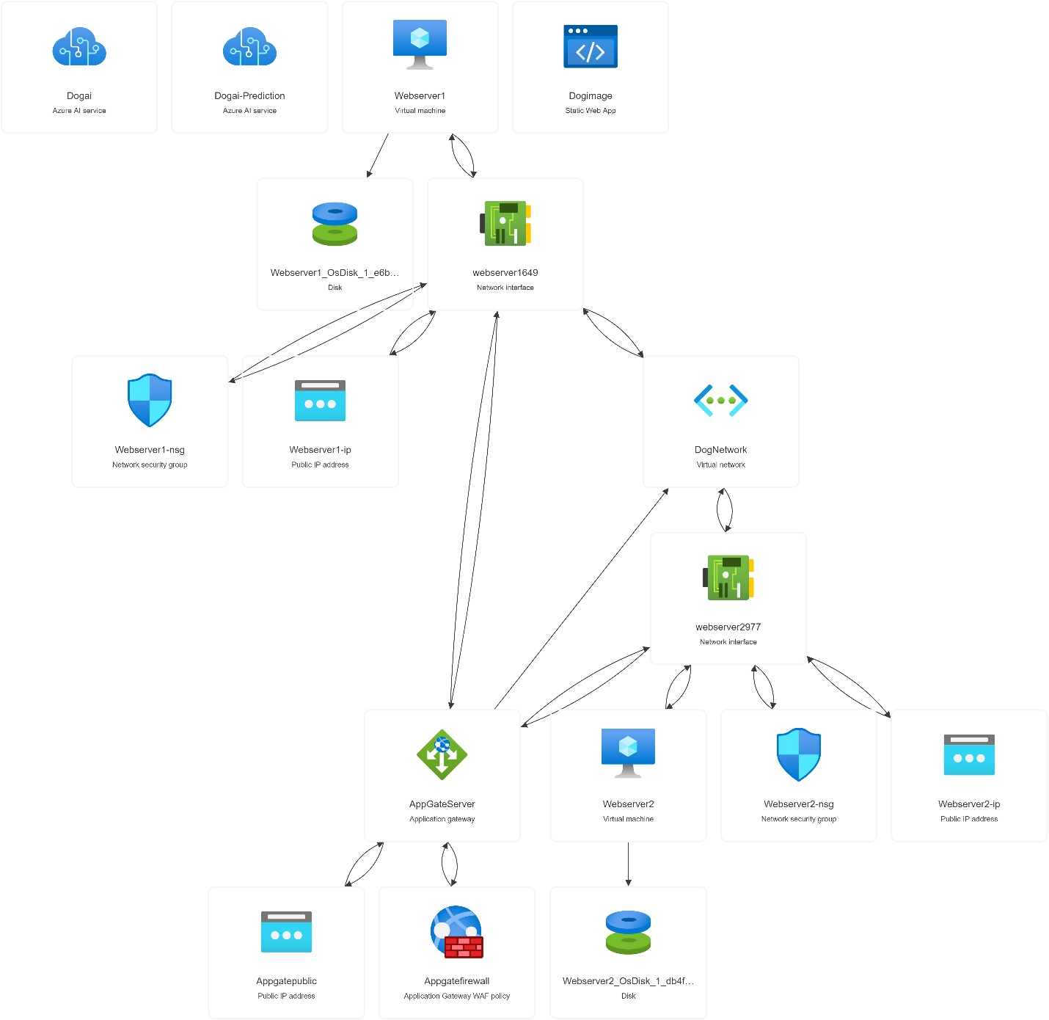

**User Instructions**

**1. Uploading an Image:**

* To begin, visit the Dog Breed Identifier web page.
* Look for the file upload form, which is typically a button or area with the label "Upload Image" or similar.
* Click on this area to open a file dialog.
* Select an image of a dog that you want to identify from your local device. The accepted file formats will be specified on the page.

**2. Initiating Predictions:**

* Once you've selected the image, you might need to click a "Submit" or "Predict" button to initiate the prediction process.
* The web page will send the selected image to the Dog Breed Identifier's backend, powered by Azure Custom Vision AI.

**3. Viewing the Results:**

* After a brief processing time, the web page will display the results.
* You will see the predicted dog breed along with the probability or confidence score associated with the prediction.
* You can then review the results and learn about the identified breed.

**Conclusion**

In summary, the Dog Breed Identifier project represents a successful application of deep learning and machine learning techniques to classify dog breeds based on images. The project features a user-friendly web interface that enables users to upload dog images and initiate predictions. These uploaded images are processed through the Azure Custom Vision API, which employs pre-trained machine learning models to accurately identify dog breeds.

This project serves as a practical demonstration of artificial intelligence's real-world utility, showcasing its ability to excel in image recognition tasks. Its significance extends beyond dog breed identification, serving as a testament to the potential of AI in solving practical challenges.

As a concluding thought, the Dog Breed Identifier project has the potential for further enhancements in user experience, accuracy, and scalability. With continuous training using a diverse dataset of dog images and refining the interface, it can become an even more valuable tool for dog enthusiasts and professionals in the field of animal care

**Step by Step Process of making project**

Login into Azure > Go to search bar and search for Azure Custom vision > Create > Create new Resource GROUP , Name and select region , Create option = Both

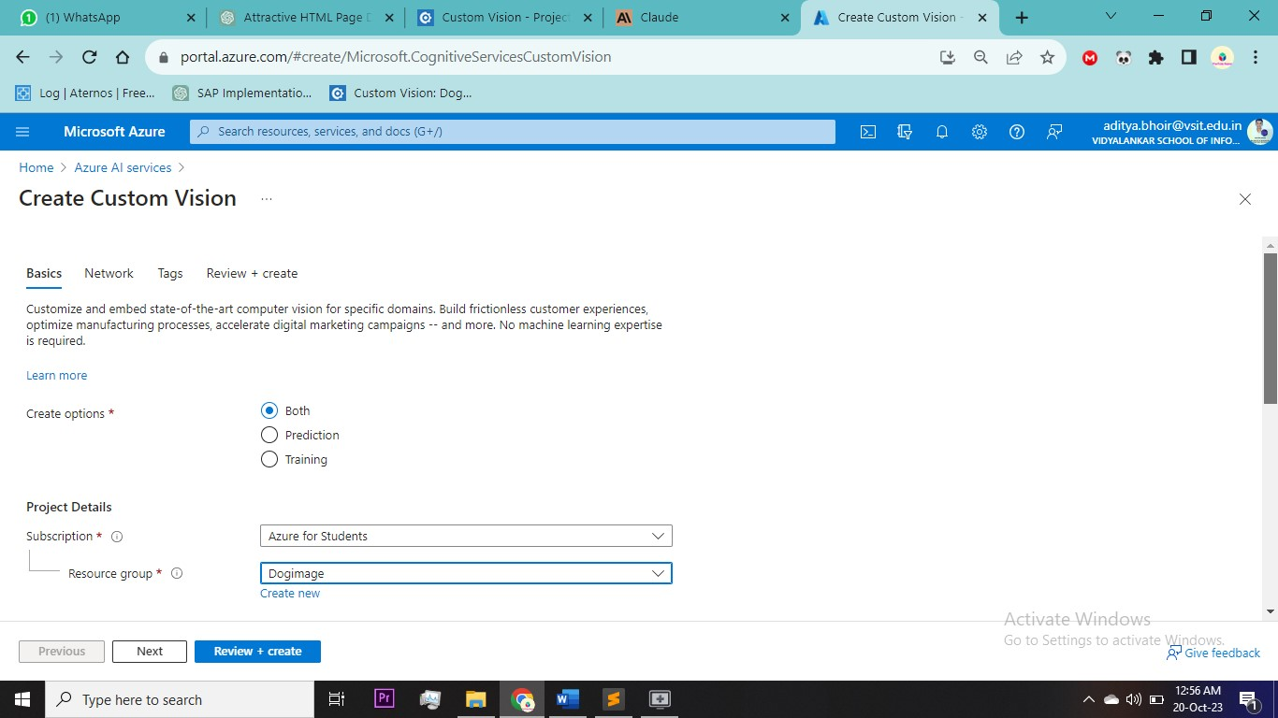

Select the pricing tier I will select free tier for both Training and Prediction

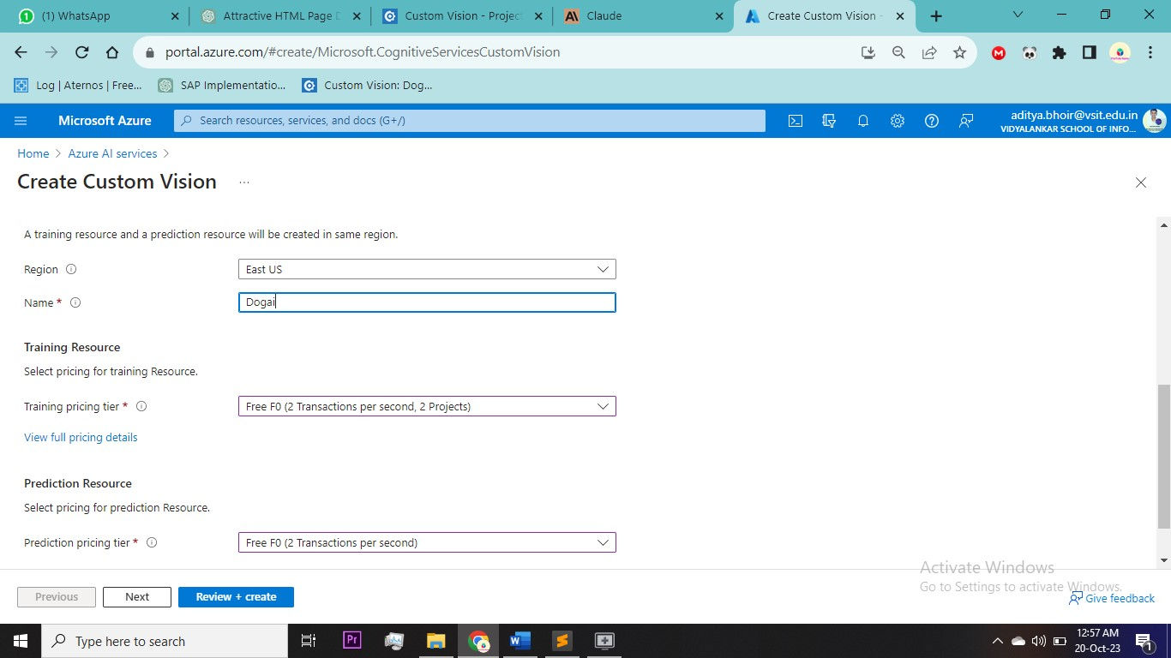

In network I will select access to everyone as this website is globally accessible from anyone > Review&create

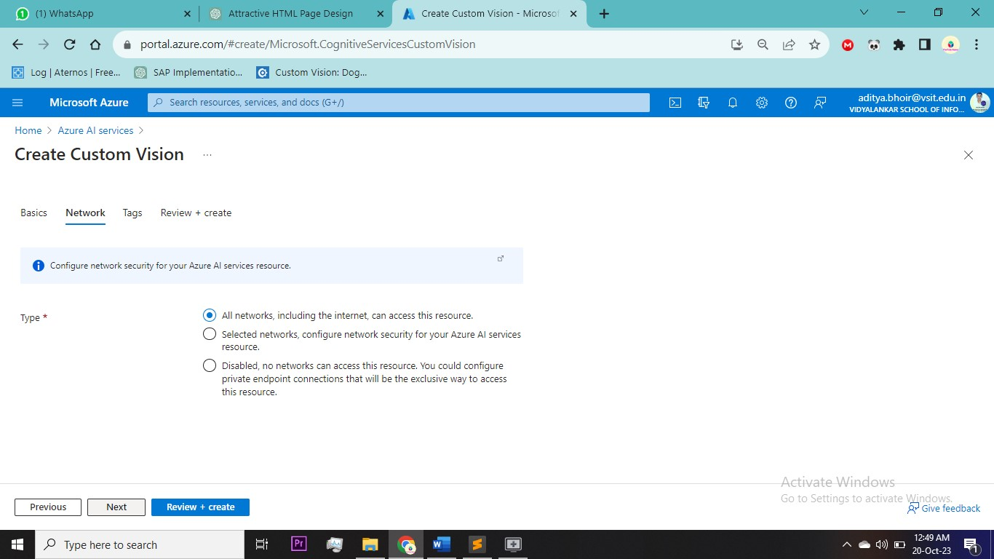

Now after creating go to google and search for custom vision open it select create new project

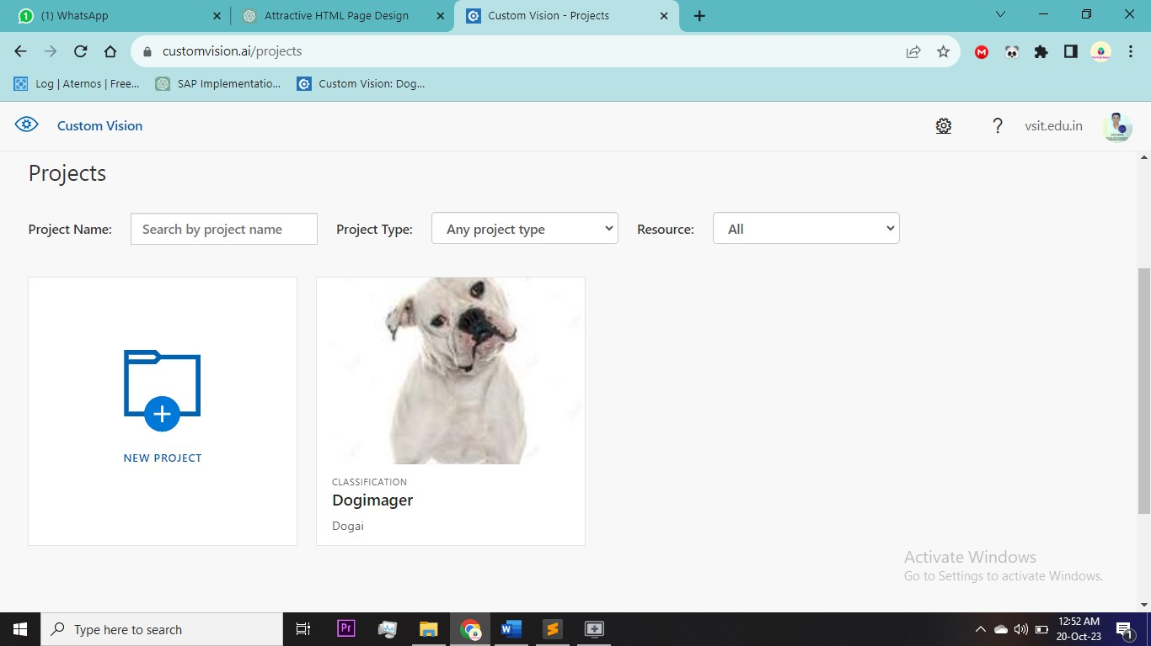

Add name and description and select project type = Classification (as I want to classify between different dogs ) and classification type = multiclass

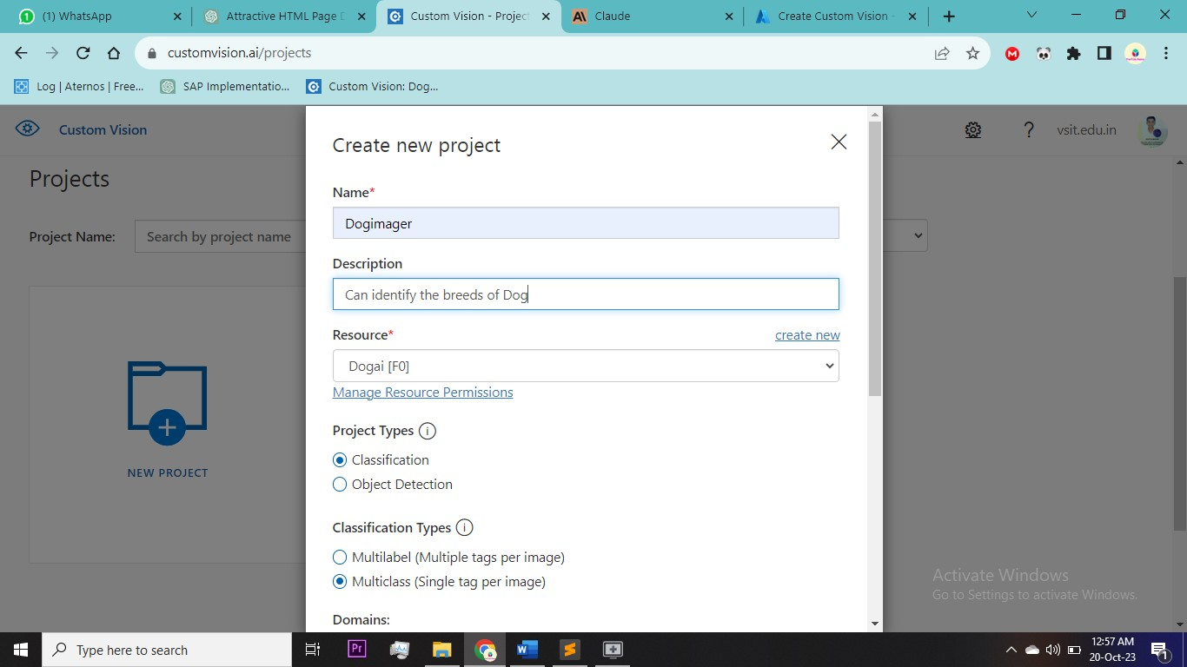

Select domain and export capabilities   
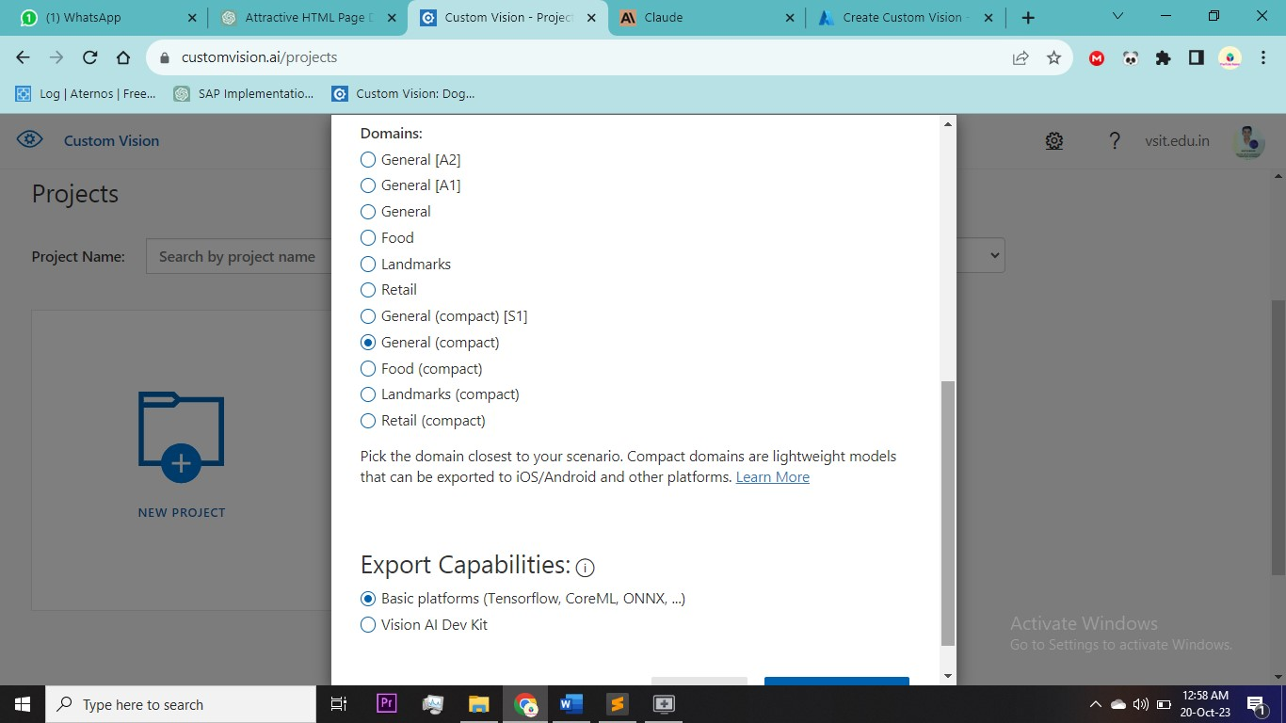

Upload images and give tags (5 images per tag)

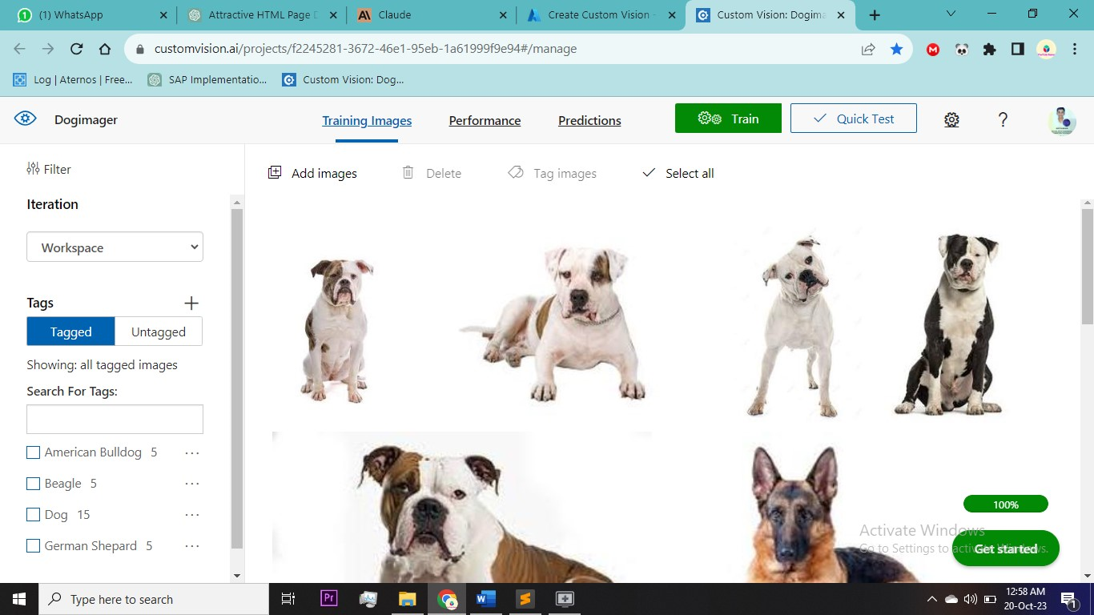

After adding images click on train to train AI. I have choose to quick train as it is easy

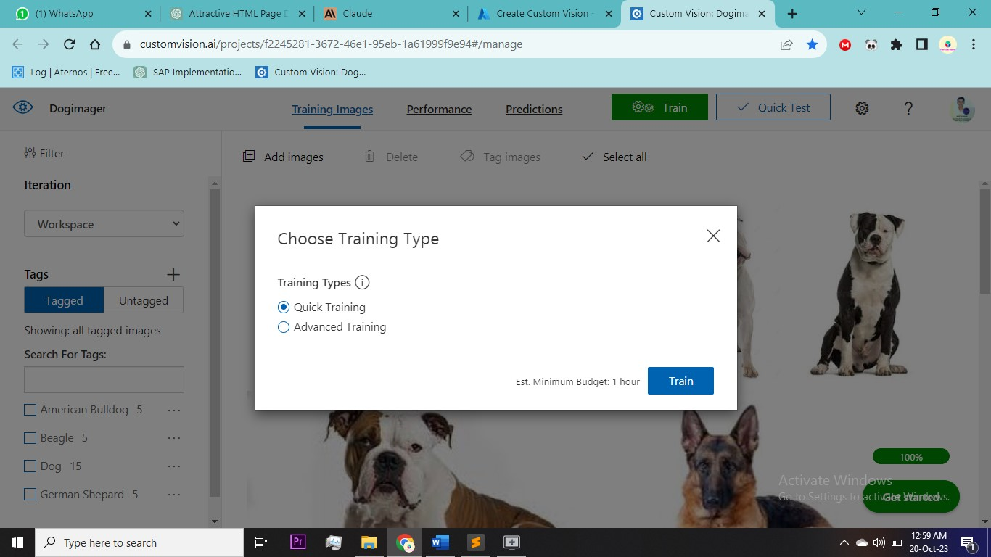

After training you will reach to performance tab where you can see analytics . click on prediction URL to get the url and prediction key so that you can integrate it various apps

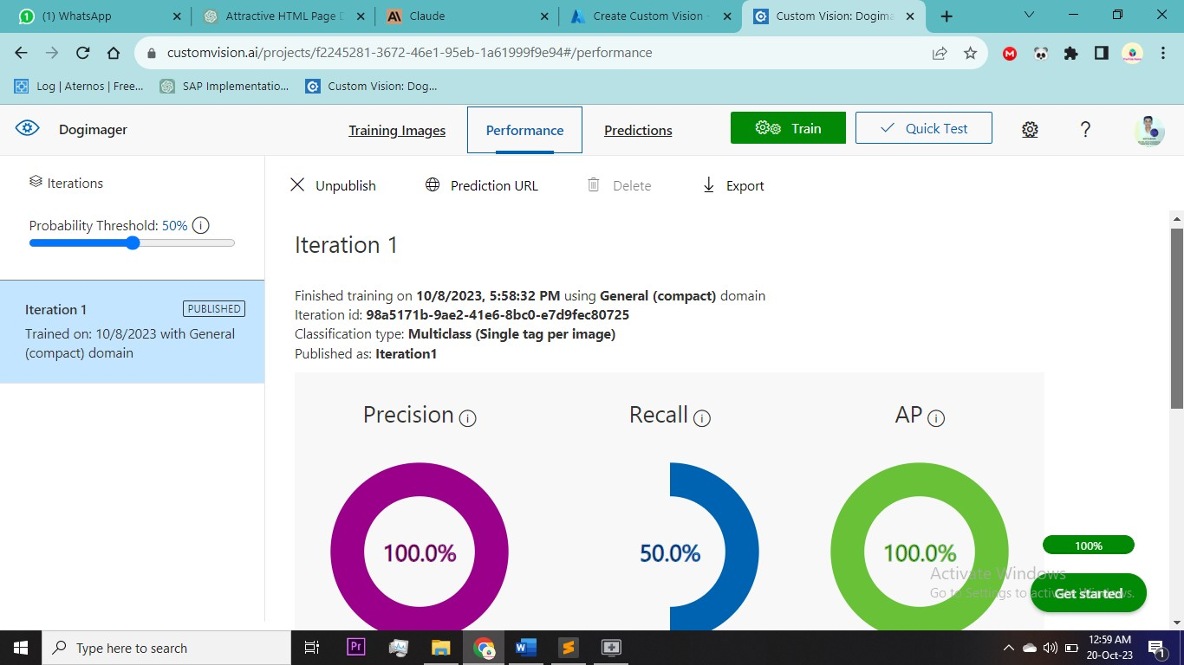

Now go to Virtual Network > Create

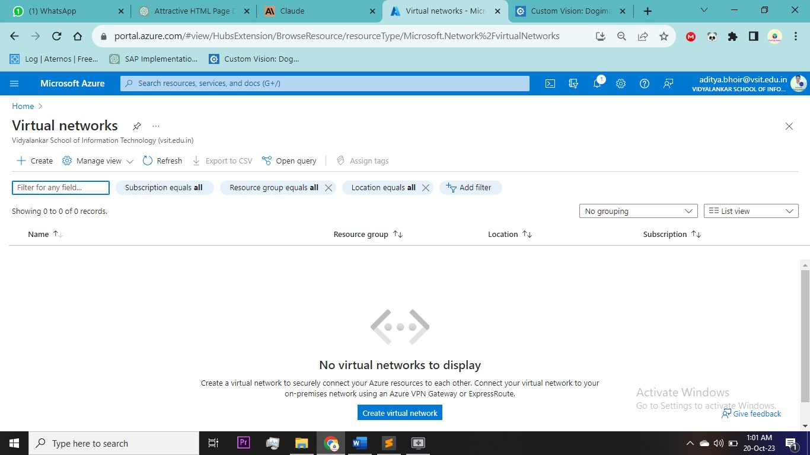

Select same resource group and fill basic details

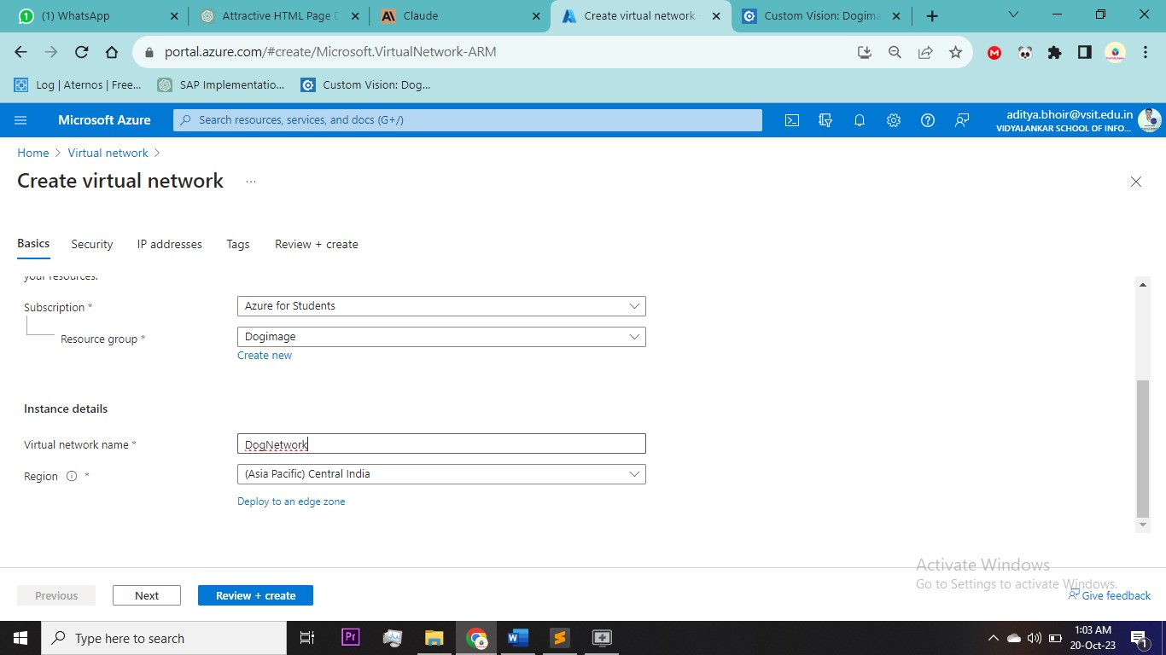

Add two subnet one for webservers and another for Application Gateway > Review & Create

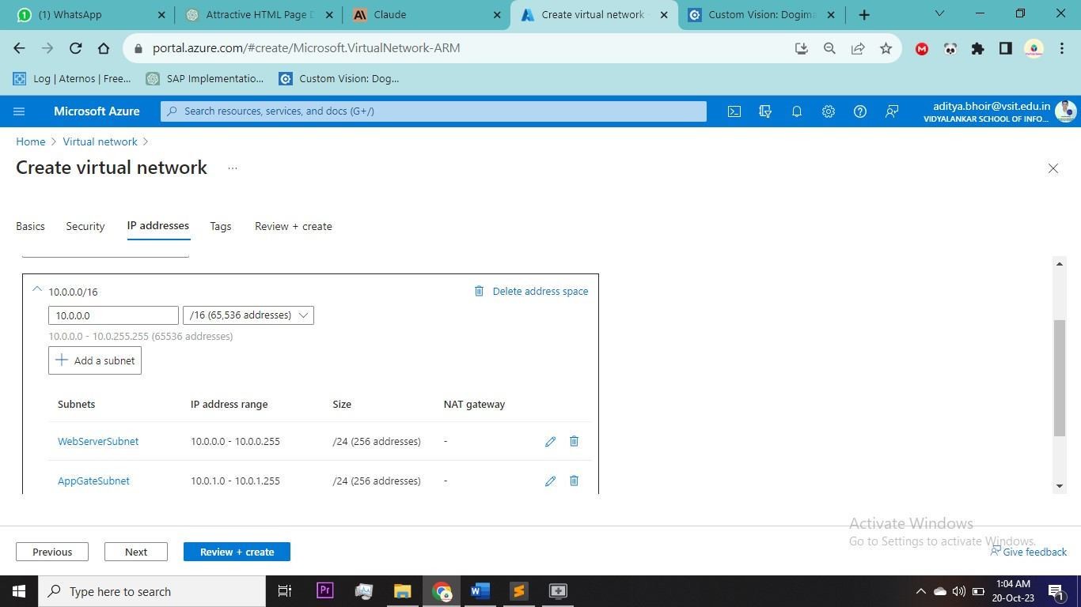

Now Create Two Virtual Machine fill out basic details > image = windows 2022 , Aviability = none, security type = standard

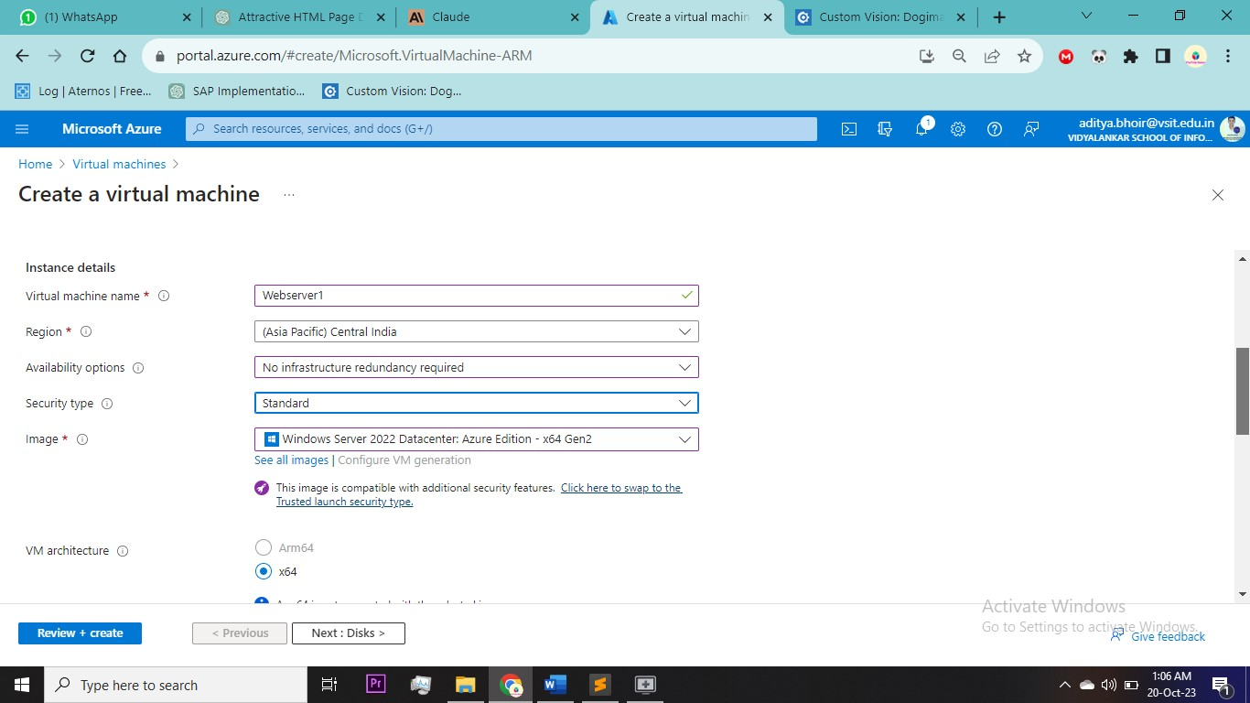

Create a username and password add two ports RDP and HTTP

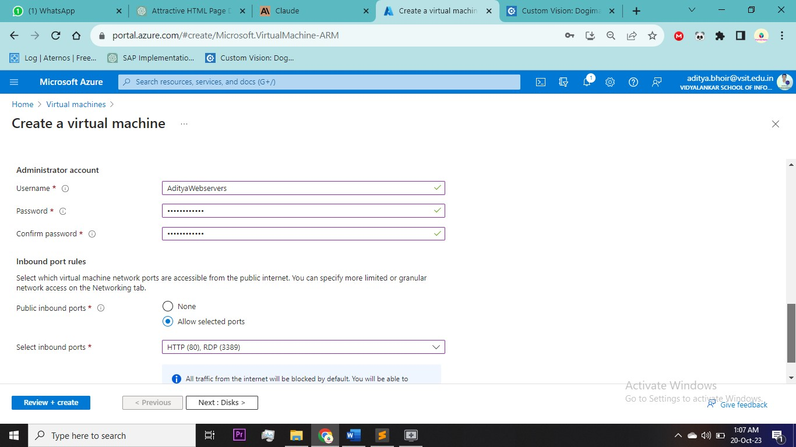

Select the virtual network in networking Section > Subnet = webserver > Review & Create

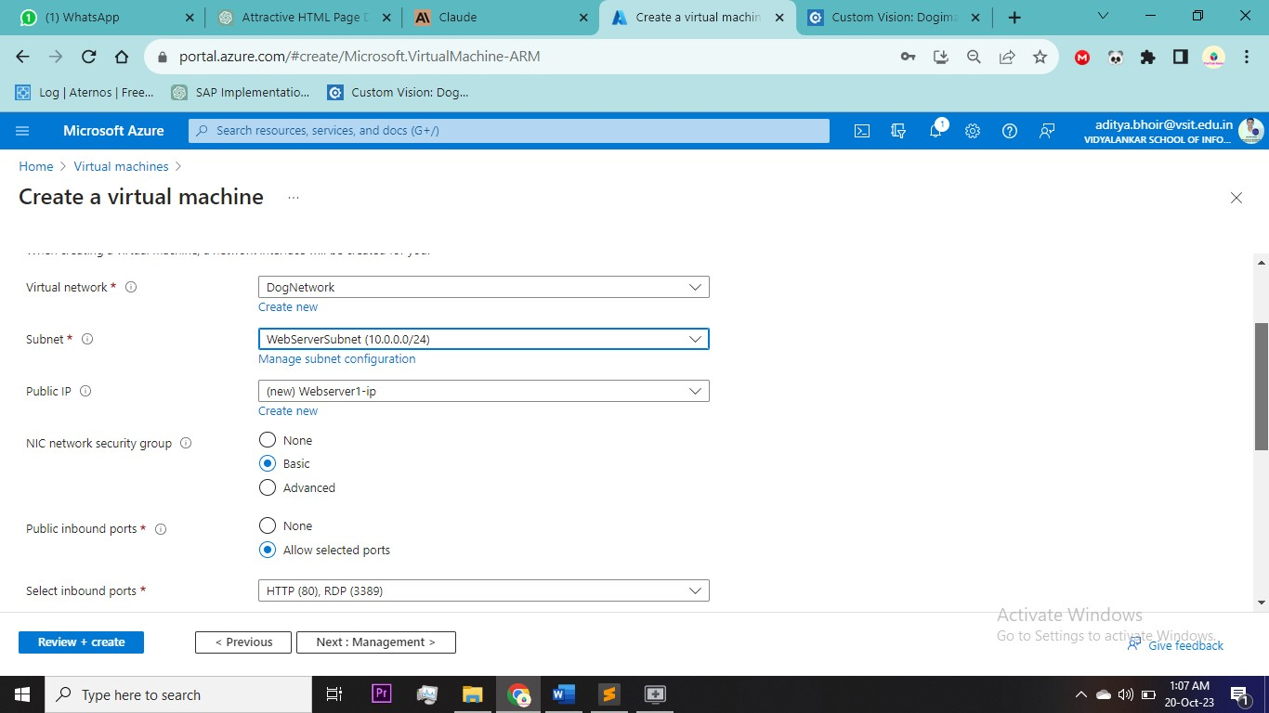

Second Virtual Machine same process

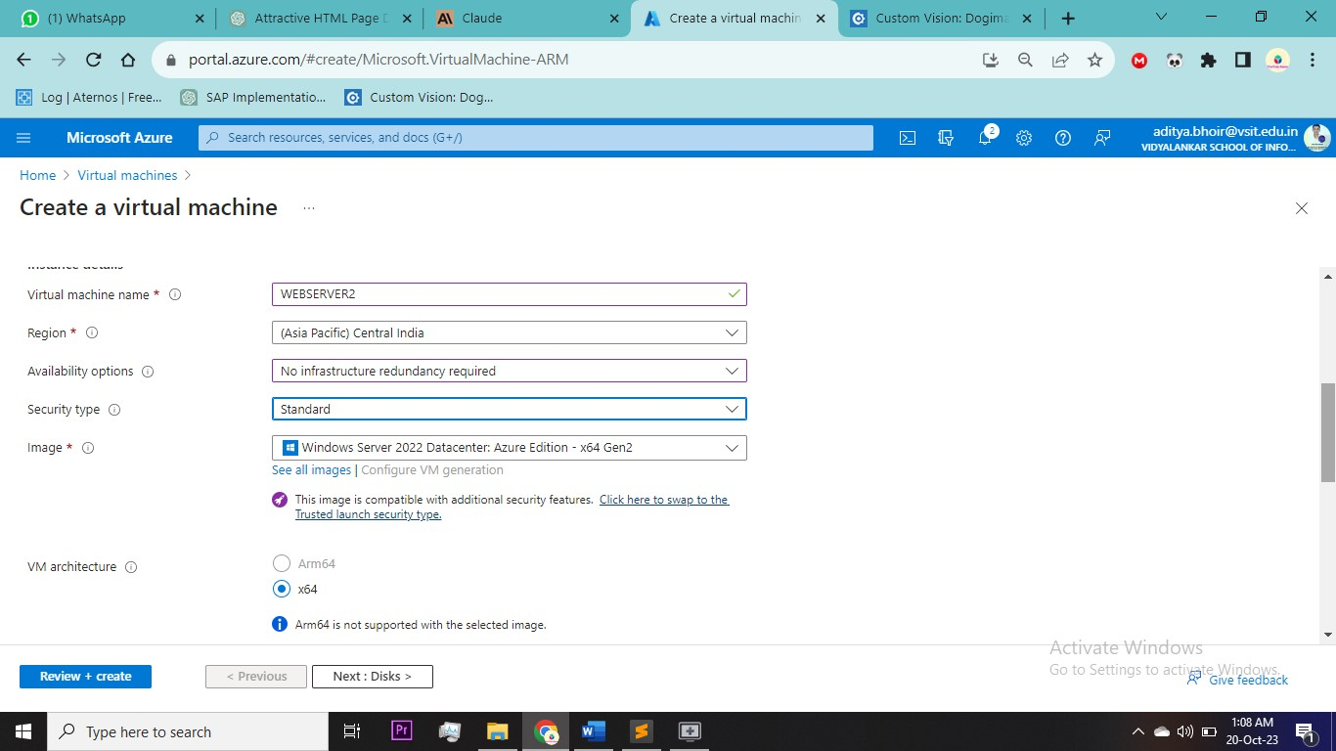

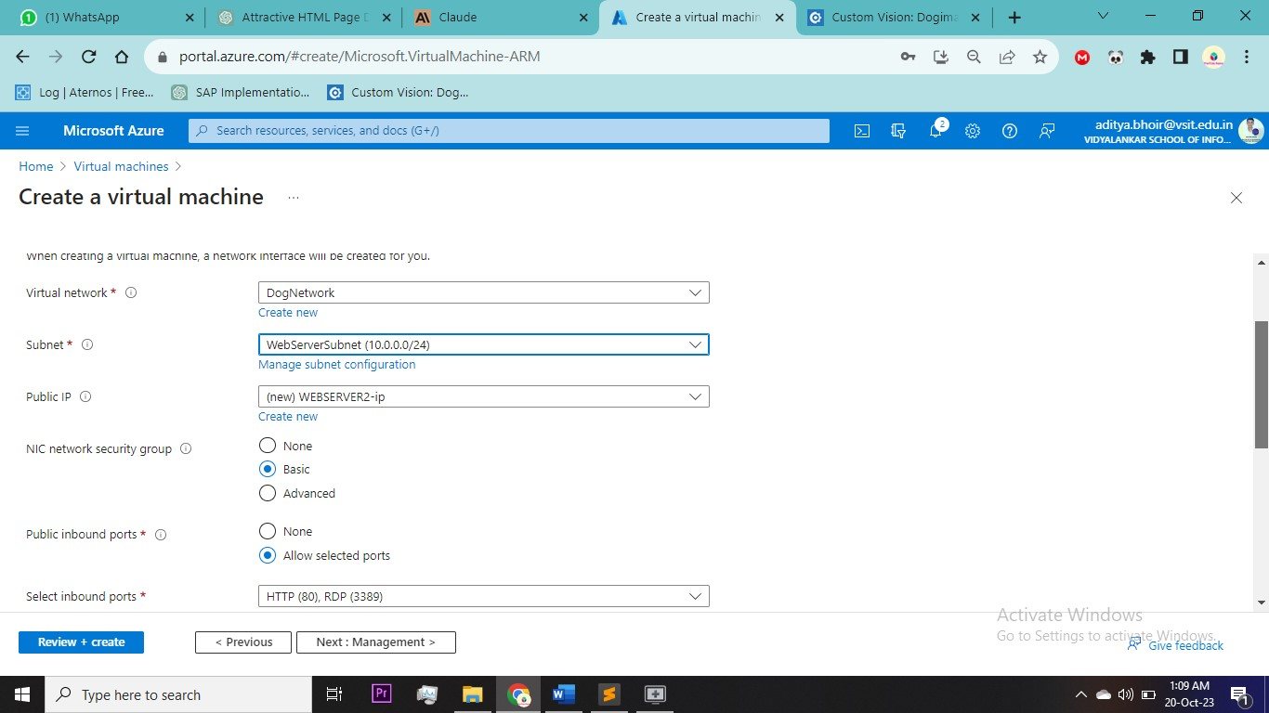

Now go to Application Gateway from the search bar > create

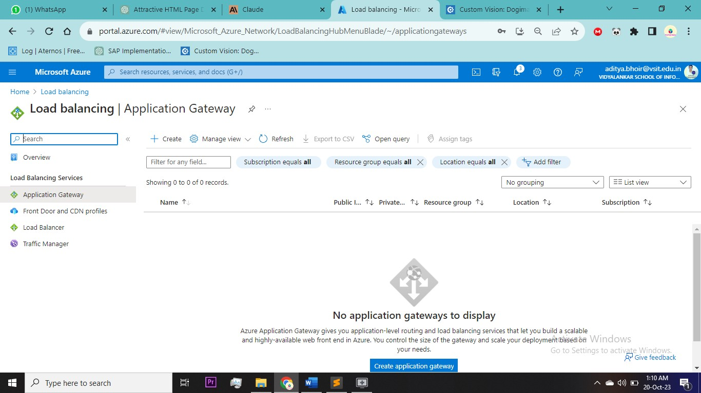

Fill out the basic Details > tier = WAFV2, enable autoscaling = no > Select Virtual NETWORK > select subnet created for Application Gateway

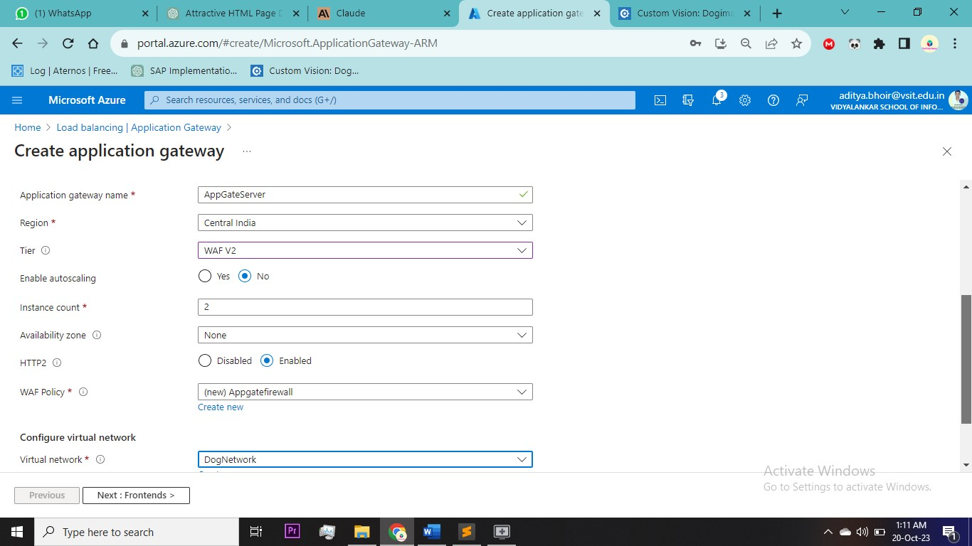

To create Web Application Firewall policy you can directly create while creating Application gateway

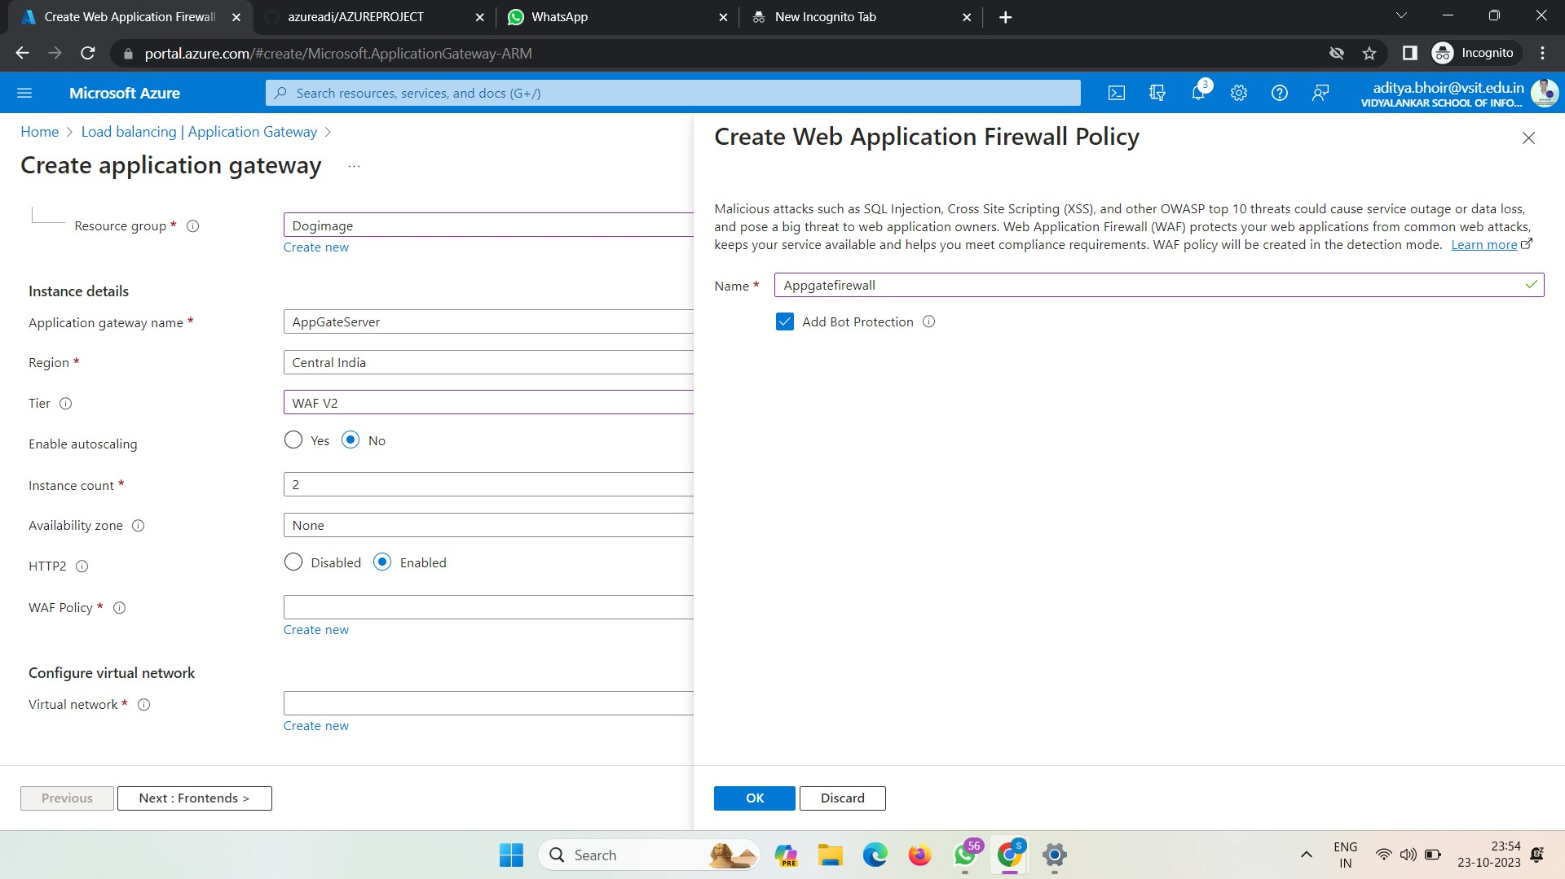

Add new Frontend Public Ip

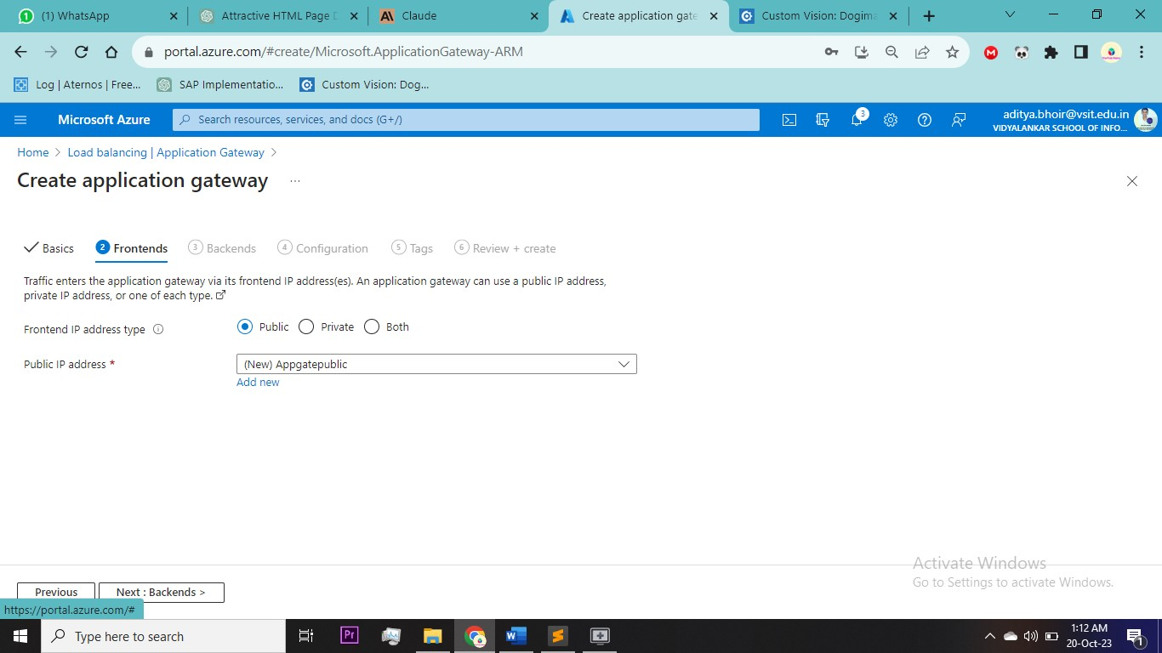

Add new Backend pool and select both the VM

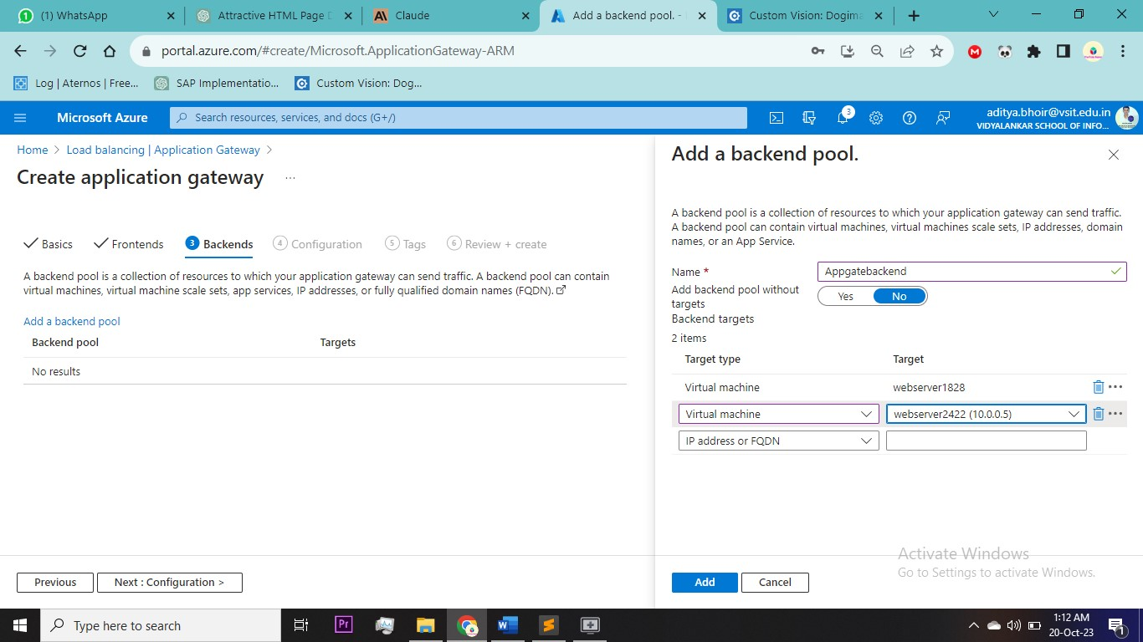

Add new Routing Rule > name , priority , Select target type backend you created > Backend setting – Add new

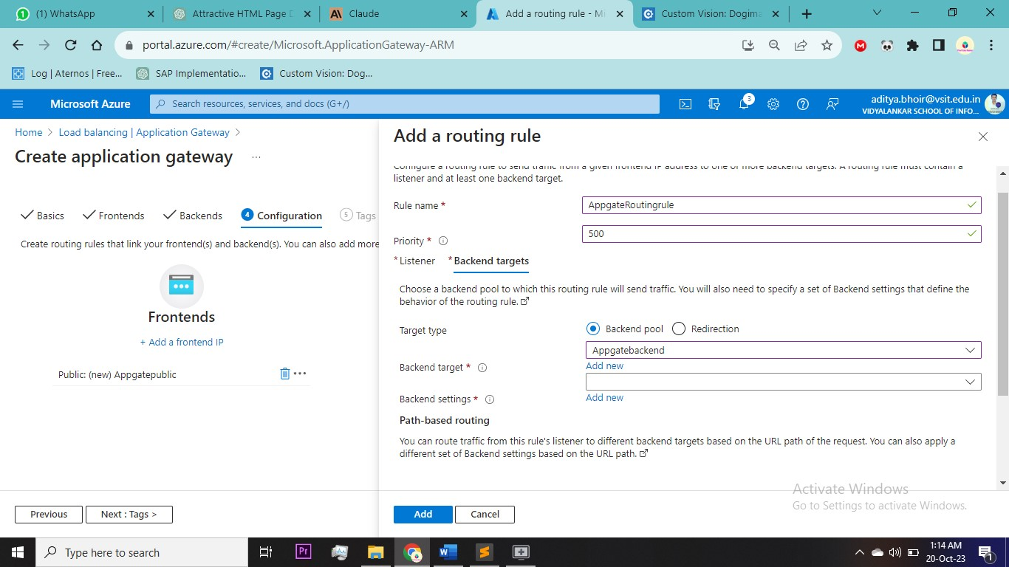

Add Backend Setting name and rest will be default > review & Create

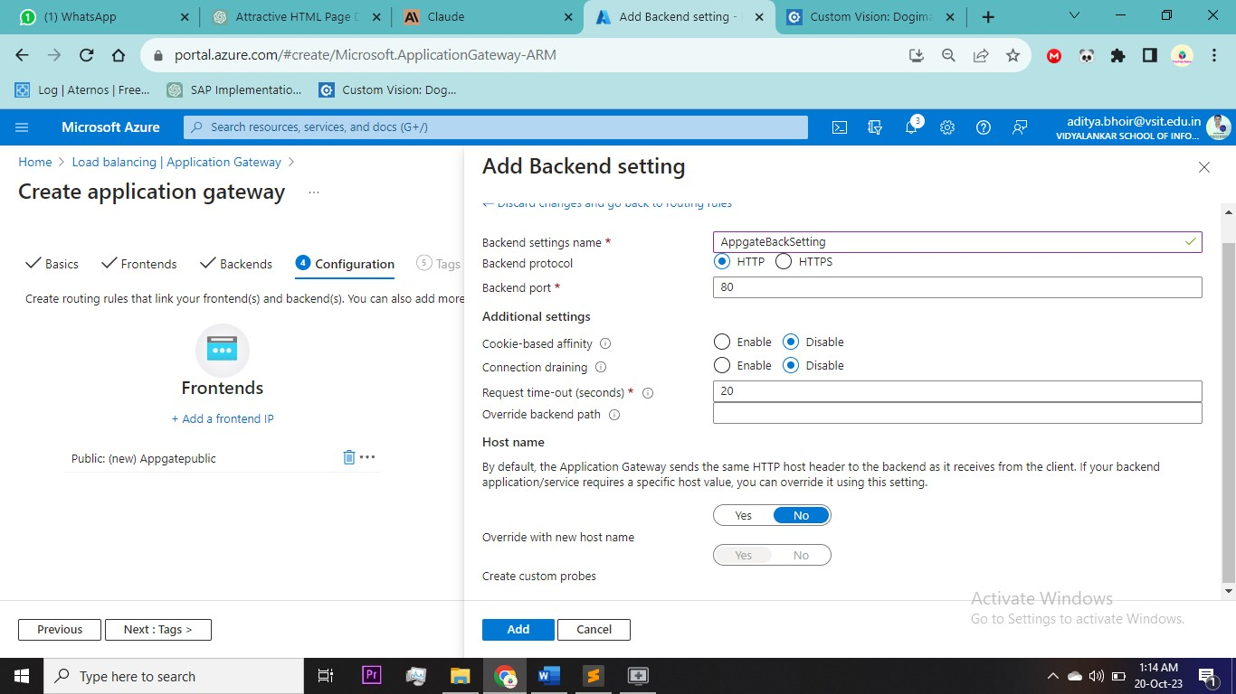

Go to Virtual Machine 1 connect it

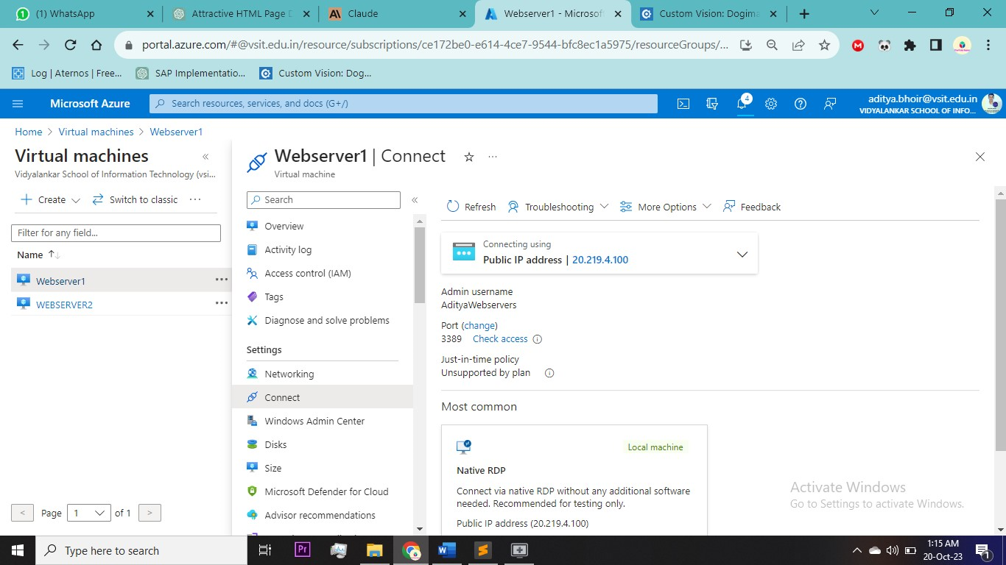

Click on Add roles and feature  
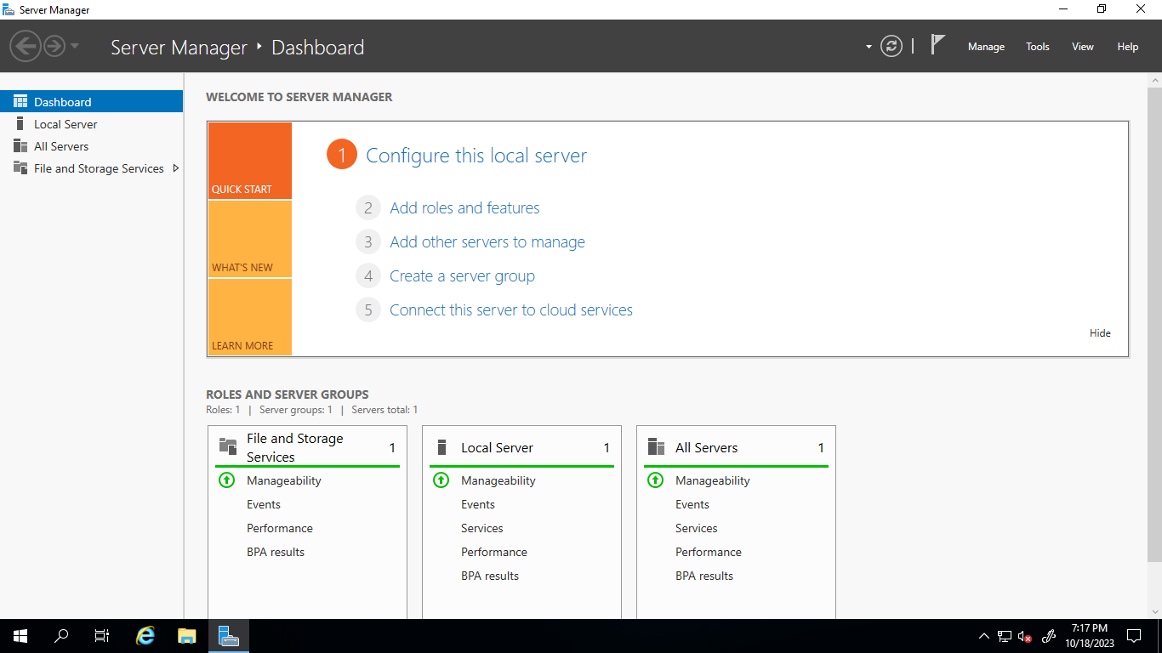

Click Next  
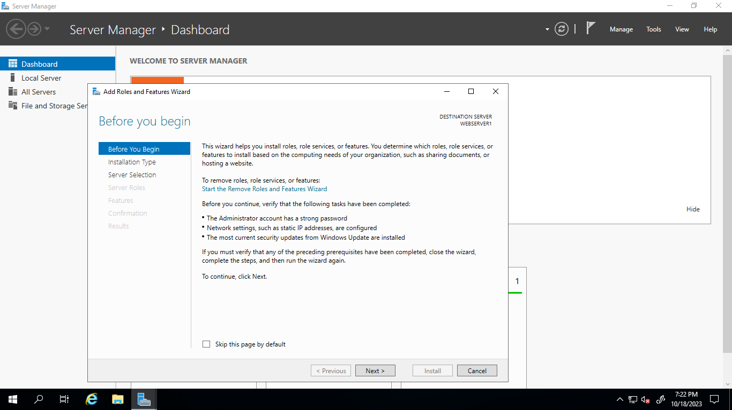

Select Web Server(IIS) > click Next and install

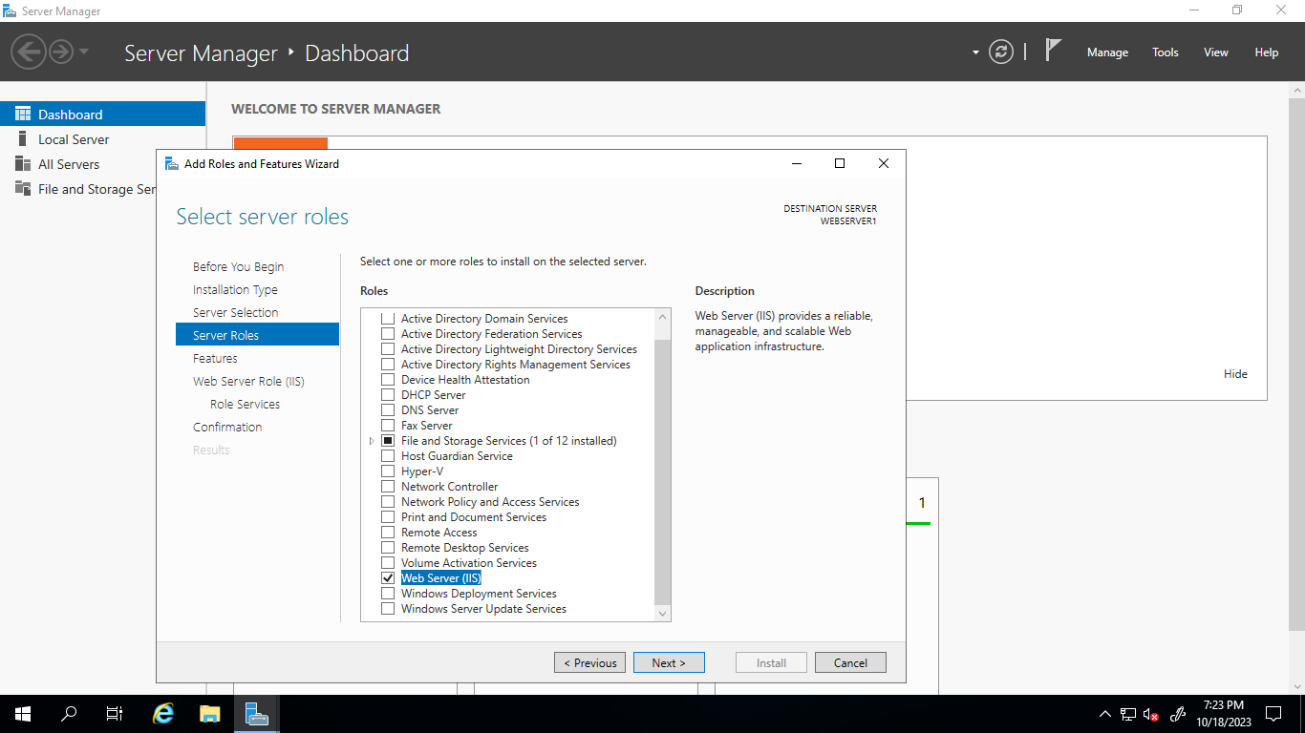

Now open This PC and Go to C drive > inetpub> wwwroot

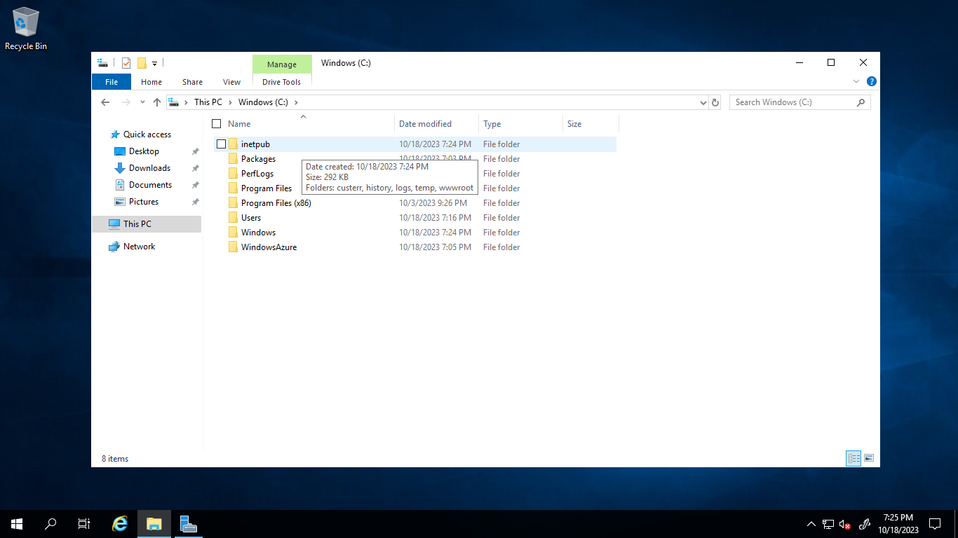

Delete both the files and paste your own html and js file

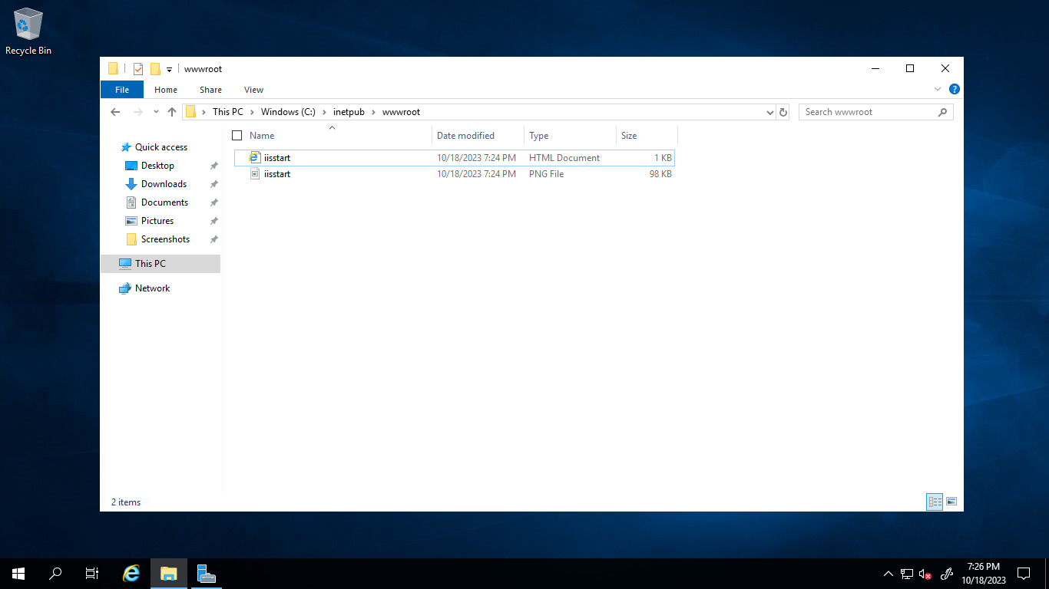

Same method for Virtual MACHINE 2

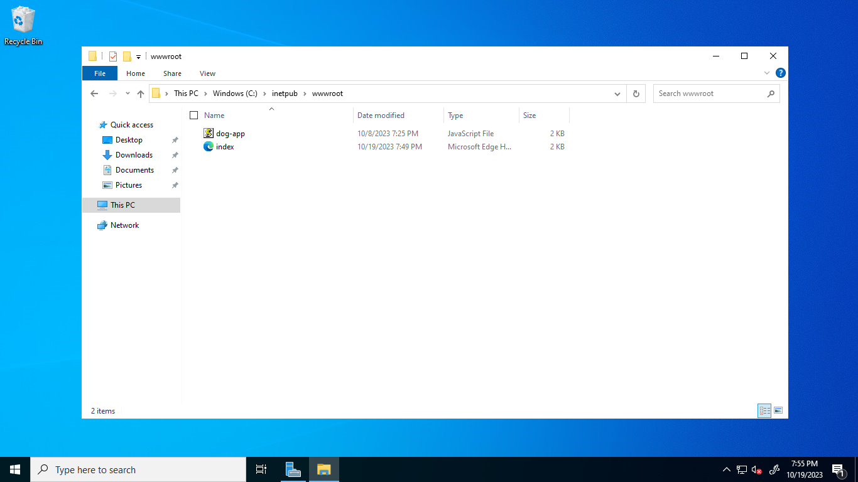

Now go to Application Gateway

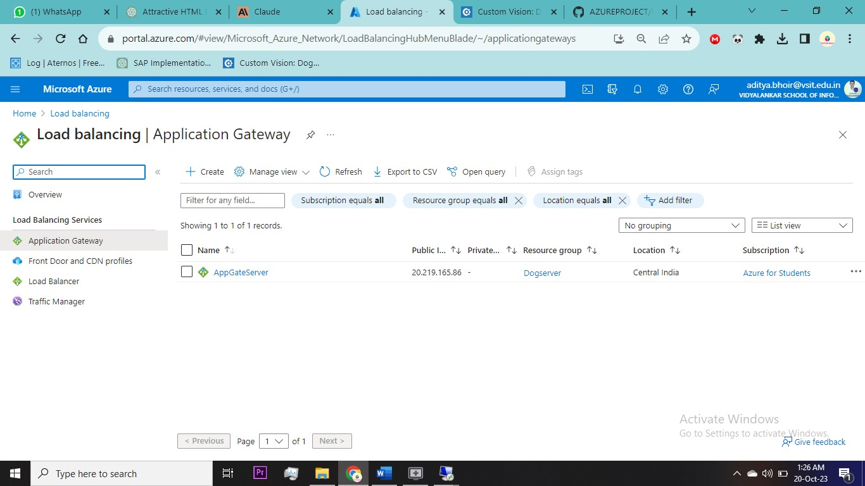

Go inside Frontend Ip

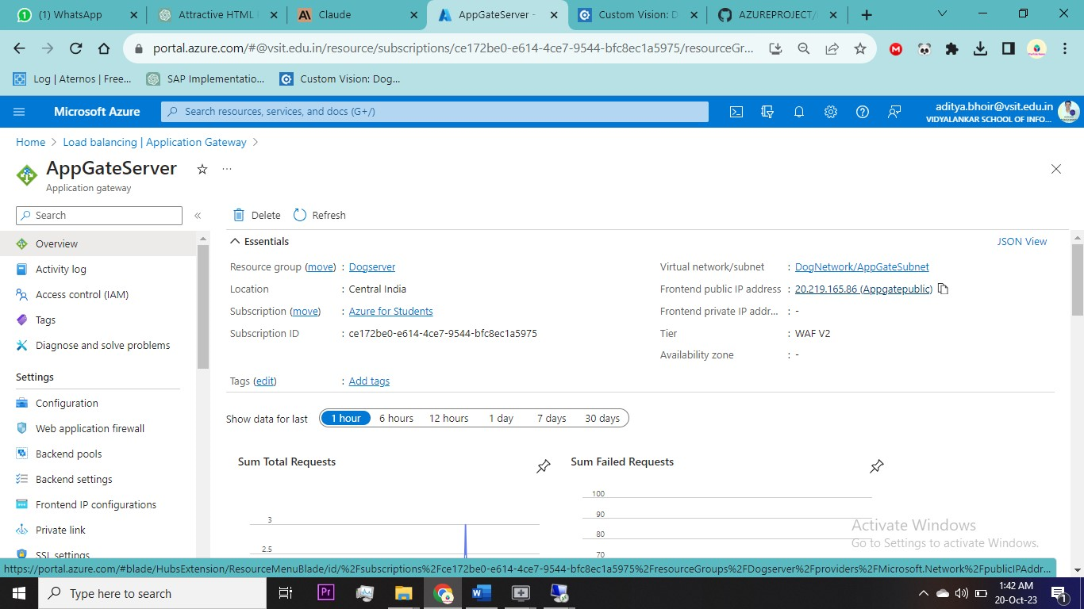

Inside Frontend go to Configuration and add DNS name

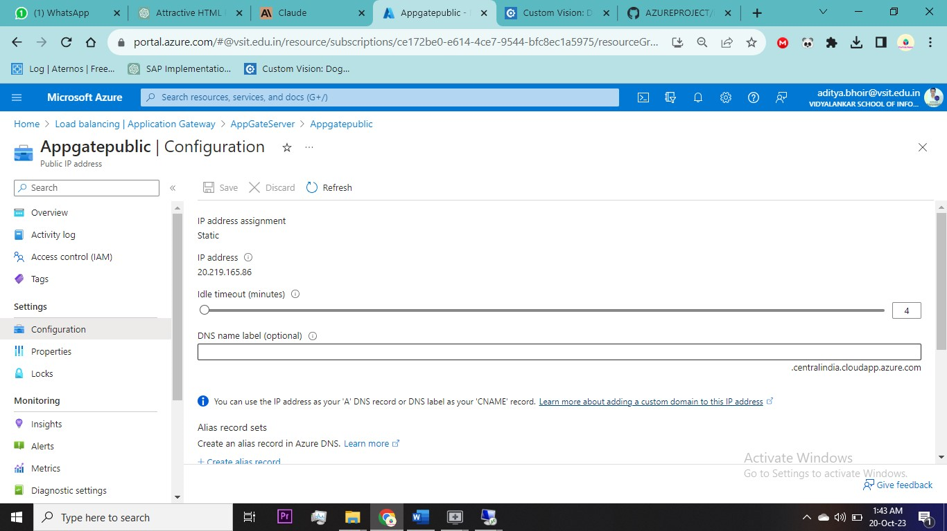

You can also Check Backend Health

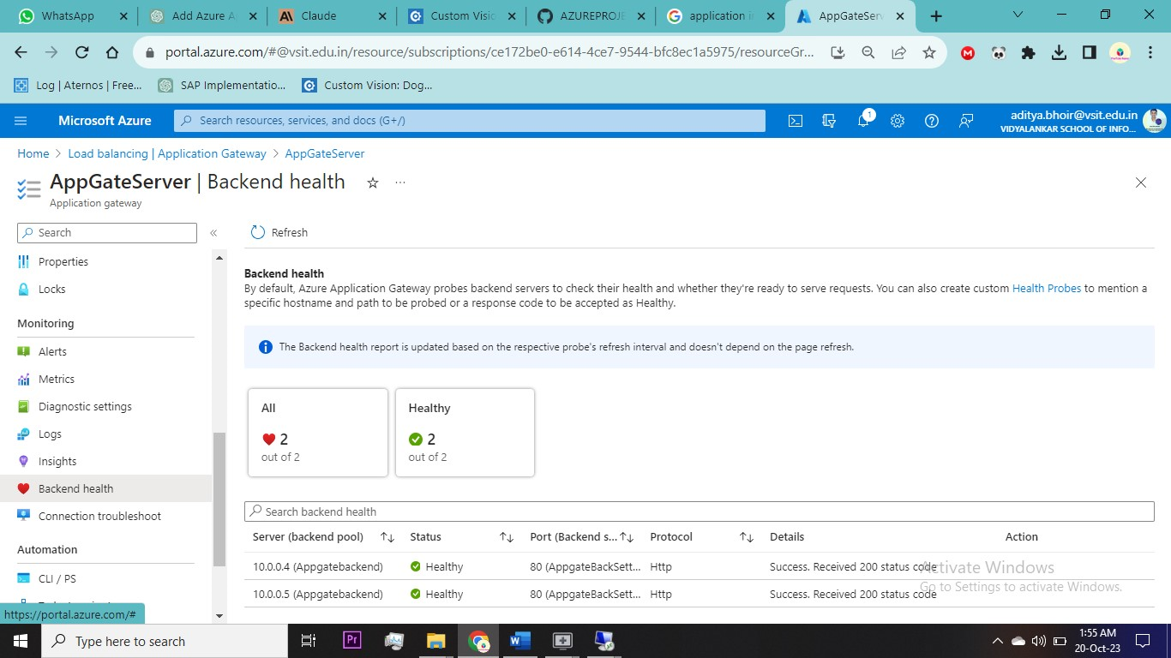

**RESULT**

Copy Pubic Ip of Application Gateway and Paste in new tab Upload a dog photo & click predict

